Odd, Even, Periodic

 is an even function if the graph  is symmetrical in the y axis: 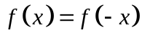
is an odd function if the graph has rotational symmetry about the origin: 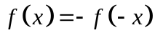
is a periodic function if the graph repeats itself along the x axis: the interval after which it repeats is called the period

Function | Odd, Even, Neither | Period (in radians)
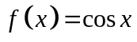

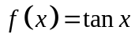

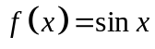

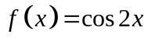

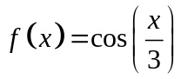

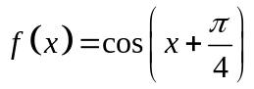

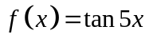

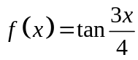

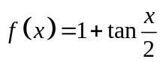

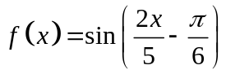

Odd, Even, Neither?

Odd

Even

Example

Are the following functions odd, even or neither?

(a) 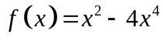

(b) 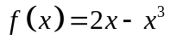

(c) 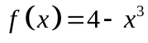

(d) 